Table 1: Image Acquisition Parameters of the LiTS Challenge for the Training, Validation, and Test Sets
Origin | Distribution | Mean (Min-Max)
 |  | Slice Thickness (mm) | Pixel Size X (mm/voxel) | Pixel Size Y (mm/voxel)
LiTS | Training (n = 72) | 1.64 (0.7-5.0) | 0.75 (0.60-0.98) | 0.75 (0.60-0.98)
 | Validation (n = 20) | 2.02 (0.7-5.0) | 0.78 (0.68-0.98) | 0.78 (0.68-0.98)
 | Test (n = 70) | 2.43 (0.45-6.0) | 0.75 (0.60-0.98) | 0.75 (0.60-0.98)
3D-IRCADb | Test (n = 15) | 1.78 (1.0-4.0) | 0.72 (0.56-0.87) | 0.72 (0.56-0.87)

Table 2: Mean, Min, and Max Dice Similarity Coefficient and Median Surface Distance and Sensitivity for Individual Disease Sites by Differing Size Criteria of the 3D-IRCADb Dataset
Disease Site Diameter | # Sites | Dice Similarity Coefficient |  |  | Median Surface Distance (mm) |  |  | Sensitivity
 |  | Mean | Min | Max | Median | Min | Max
< 15 mm | 73 | 0.16 | 0.00 | 0.89 | 28.25 | 0.67 | 108 | 23% (15 of 73)
≥ 15 mm | 48 | 0.74 | 0.00 | 0.94 | 1.23 | 0.28 | 19.4 | 98% (47 of 48)

Table 3: Comparison of CRLM Segmentation Results from Our Model and the Literature. Green Box Indicates More Disease Sites (n), Better Dice Similarity Coefficient (DSC), or Higher Sensitivity.
Method | Model | Disease Diameter and Source | No. of Sites | Mean DSC | Sensitivity
Presented method | Hybrid-WNet | < 10 mm | 42 | 0.00 | 7%
 |  | 10-20 mm | 49 | 0.43 | 59%
 |  | 15-20 mm | 18 | 0.68 | 94%
 |  | ≥ 20 mm | 30 | 0.77 | 98%
 |  | LiTS | 70 patients | 0.810 global | -
 |  | 3D-IRCADb | 15 patients | 0.69 | -
Vorontsov et al⁴ | FCN | < 10 mm | 30 | 0.14 | 10%
 |  | 10-20 mm | n = 35 | 0.53 | 71%
 |  | > 20 mm | 40 | 0.68 | 85%
Li et al¹⁰ | Hybrid Dense UNet | LiTS | 72 patients | 0.824 global | -
Seo et al¹⁶ | mU-Net | 3D-IRCADb | 5 patients | 0.68 | -
Patients were specified instead of sites for LiTS test submission.

Table 4: Metrics of Dice Similarity Coefficient, Median Surface Distance (mm), False-Positive Discoveries (Per Patient), and False-Positive Volume (cc) for 15 3D-IRCADb Test Patients
Metric | Overall Patients (N = 15)
 | Median | Min | Max | Standard deviation
Dice similarity coefficient | 0.74 | 0.40 | 0.89 | 0.16
Global Dice similarity coefficient | 0.81 | N/A | N/A | N/A
Median surface distance (mm) | 1.95 | 0.57 | 8.00 | 1.90
False-positive discoveries (per patient) | 1 | 0 | 7 | 2.0
False-positive volume (cc) | 4.25 | 0.08 | 28.34 | 7.48
Erroneous false-positive volume (cc) | 2.35 | 0.00 | 14.56 | 5.01
Over-segmentation false-positive volume (cc) | 1.24 | 0.00 | 17.56 | 5.50
Metric | CRLM Patients (N = 15)
 | Median | Min | Max | Standard deviation
Dice similarity coefficient | 0.78 | 0.28 | 0.91 | 0.17
Median surface distance (mm) | 0.78 | 0.01 | 83.28 | 27
False-positive discoveries (per patient) | 1 | 0 | 4 | 1.2
False-positive volume (cc) | 2.43 | 0.28 | 14.47 | 4.68
Erroneous false-positive volume (cc) | 1.05 | 0.00 | 14.23 | 4.54
Over-segmentation false-positive volume (cc) | 0.73 | 0.23 | 3.68 | 0.97
Metric | Ablation Patients (N = 9)
 | Median | Min | Max | Standard deviation
Dice similarity coefficient | 0.79 | 0.42 | 0.89 | 0.16
Median surface distance (mm) | 0.76 | 0.01 | 5.72 | 1.76
False-positive discoveries (per patient) | 2 | 0 | 6 | 1.6
False-positive volume (cc) | 27.8 | 5.84 | 174.07 | 61.25
Erroneous false-positive volume (cc) | 5.62 | 0.00 | 107.47 | 32.77
Over-segmentation false-positive volume (cc) | 11.40 | 4.35 | 172.54 | 50.97

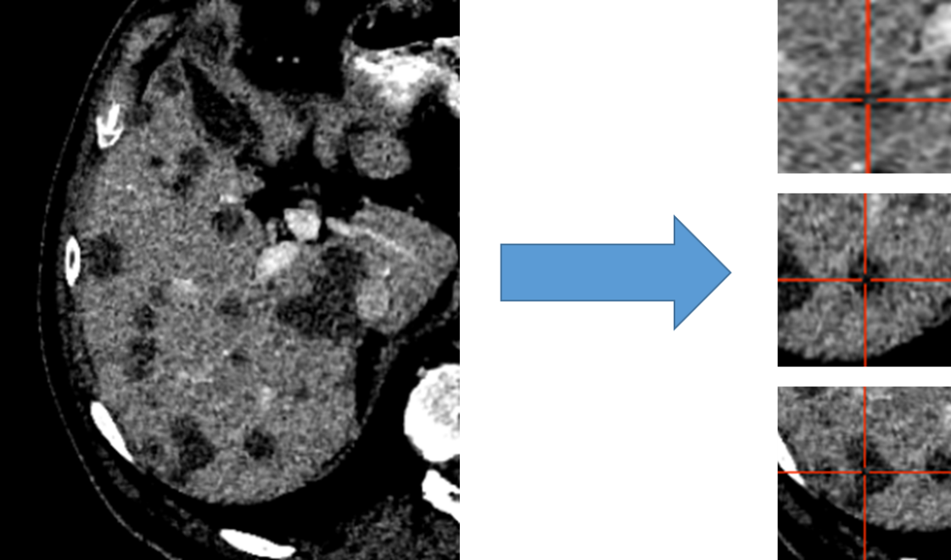
Figure 1: Liver distributed into individual cubes of 32x120x120. Disease was labeled as disease, regardless of the center of the cube. The validation and test set were not broken into cubes; our architectures accepted variable input sizes, with the entire liver being passed at once for evaluation and testing.
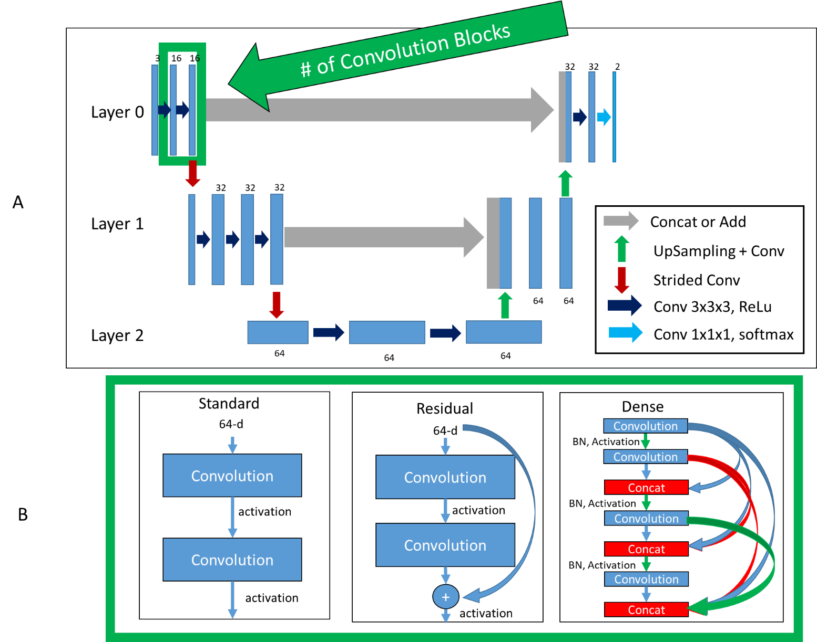
Figure 2: Top (A): Basic architecture framework. Bottom (B): Difference in convolution blocks, surrounded by green to indicate the same region in (A). Standard: previous feature maps are convolved and activated. Residual: previous feature maps are directly added to convolutional output in a skip-connection before activation. Dense: previous feature maps are continually concatenated together before activation and convolution. BN: batch normalization.
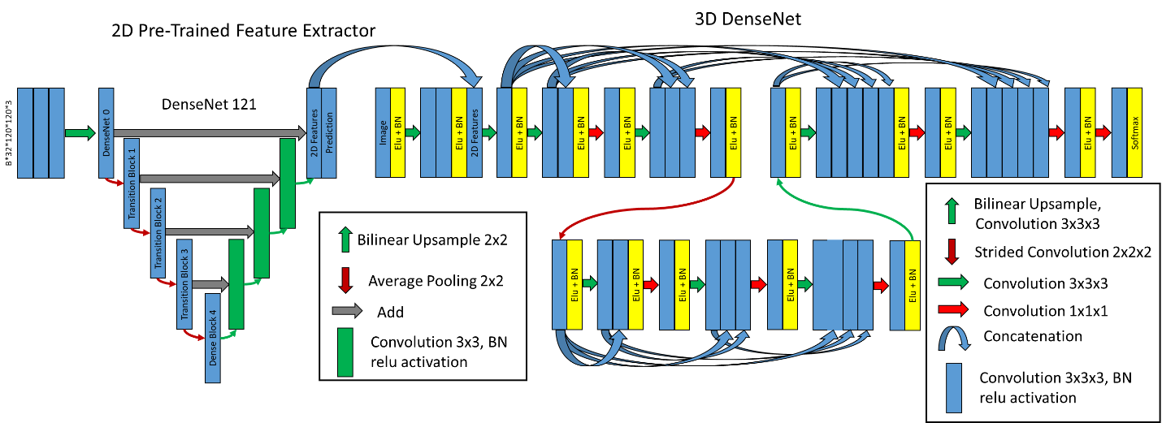
Figure 3: Hybrid-WNet. (Left) Pre-trained 2D DenseNet 121 converted into UNet, where final features, filters from 2D prediction are 32 and concatenated into 3D DenseNet. (Right) 3D DenseNet architecture was defined as two layers, two convolution blocks in layer 0, three convolution blocks in layer 1, and 8 initial filters. BN: Batch Normalization.

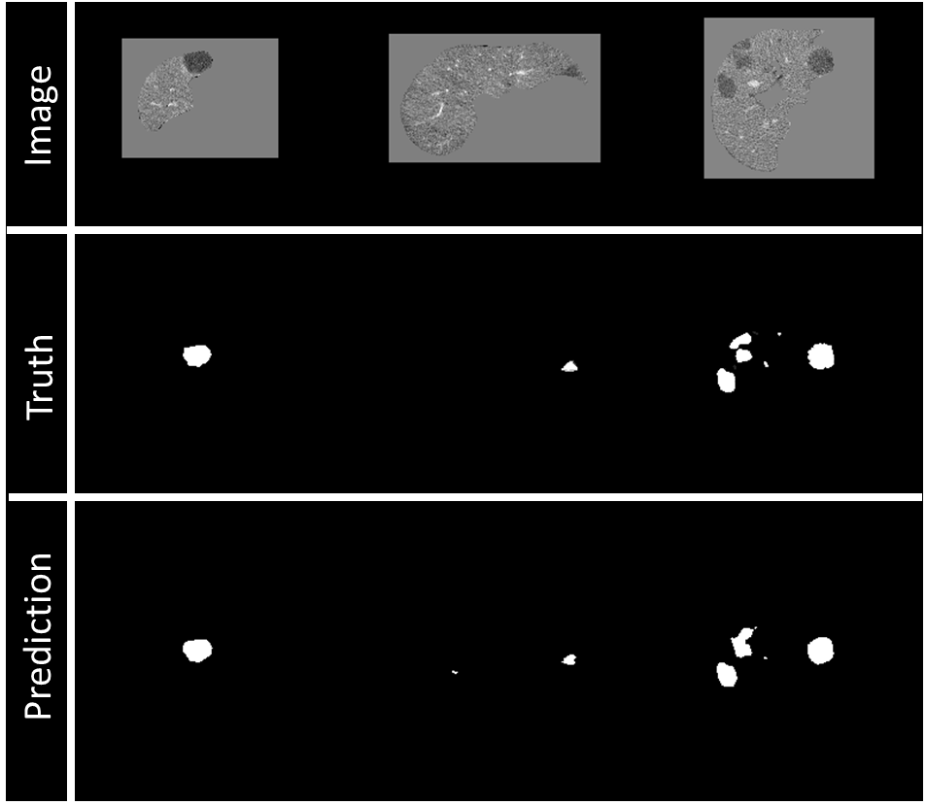
Figure 4: Example of visualization of prediction on validation data during training. Top row: Image being fed into the model, masked by the liver segmentation. Middle row: Ground truth of disease contours. Bottom row: Prediction of disease contours, set with a threshold of 0.5 to the binary mask.
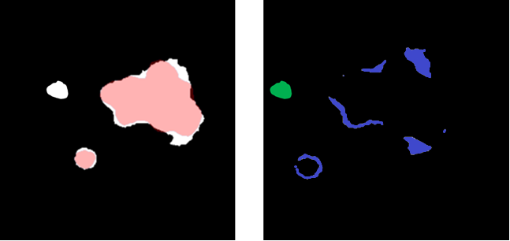
Figure 5: (Left) Overlay between predicted (white) and ground truth (red) disease segmentations. (Right) Subtraction of the predicted and ground truth disease segmentation and over-segmentation of the disease volume (blue) and unconnected erroneous false-positive region (green). The sum of blue and green is a false-positive volume.

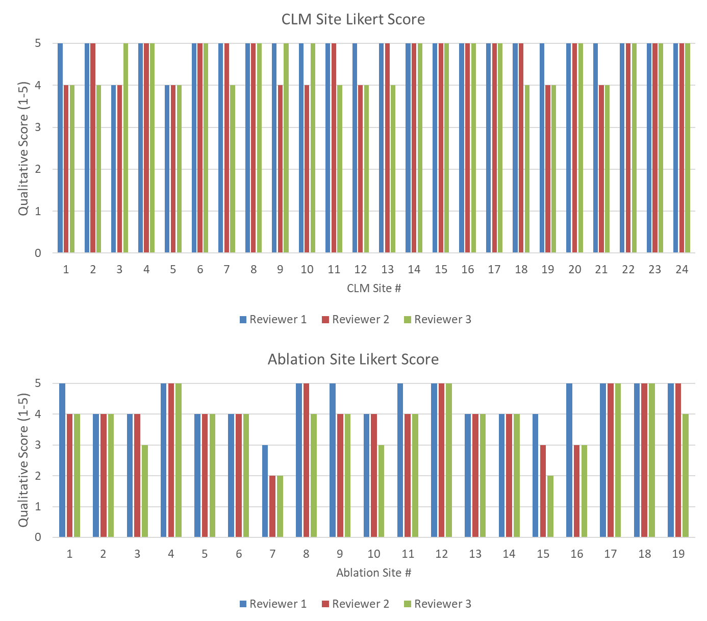
Figure 6: (Top) Likert score by each reviewer for each disease site. (Bottom) Likert score by each reviewer for each ablation site. A higher value is associated with higher quality.

Supplementary Table 1: Likert Scoring for Assessment of Colorectal Liver Metastasis (CRLM) and Ablation Contours
Score |  | Criteria
5 | Excellent | Negligible changes, could be used clinically without edits
4 | Good | Minor changes on < 4 slices or changes that would take < 10 seconds to fix
3 | Fair | Edits needed on multiple slices, but < 50%
2 | Poor | Edits needed on > 50% of slices
1 | Very poor | Contours are poorly predicted, missed disease

Supplementary Table 2: Breakdown of Likert Score (1-5) for Predicted Contours of CLM and Ablation Sites by Each Reviewer
 | CRLM Scoring (n = 24)
 | Reviewer 1 | Reviewer 2 | Reviewer 3 | Majority Vote
Mean | 4.9 | 4.7 | 4.6 | 4.8
Min | 4 | 4 | 4 | 4
Max | 5 | 5 | 5 | 5
% ≥ 4 | 100 | 100 | 100 | 100
 | Ablation Scoring (n = 19)
 | Reviewer 1 | Reviewer 2 | Reviewer 3 | Majority Vote
Mean | 4.5 | 4.1 | 3.8 | 4.1
Min | 3 | 2 | 2 | 2
Max | 5 | 5 | 5 | 5
% ≥ 4 | 95 | 89 | 74 | 84
% ≥ 4 is the percentage of cases with a Likert score of ≥ 4.

